This Is The Title of My Document

Stephen N. Spencer*
Chair, ACM SIGGRAPH Publications Committee

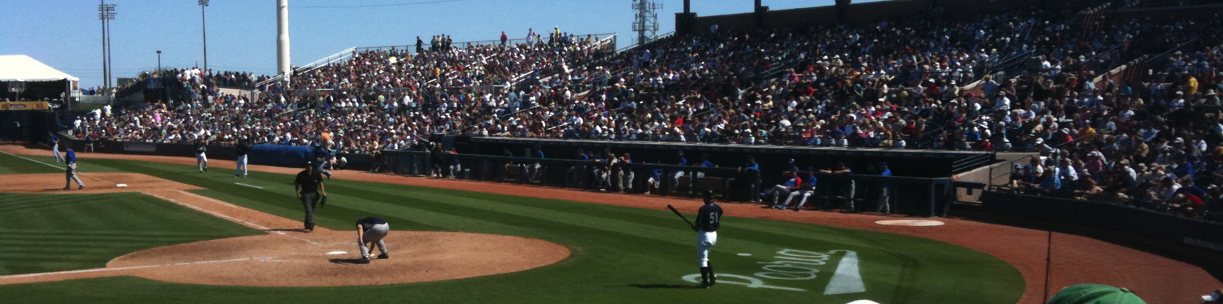

Figure 1: Spring Training 2009, Peoria, AZ.

Abstract

In this sample paper, we describe the formatting requirements for content accepted to SIGGRAPH-sponsored events. The same format can be used for content ranging from a one- or two-page Poster or Talk abstract, to a full-length Technical Paper.

Authors are now responsible for adding the appropriate rights management text to their final content, by adding information found on one’s completed rights management form to the source document.

Authors are now required to use ACM’s current Computing Classification System for the inclusion of appropriate subject concepts.

Please view the accompanying README file for a complete description of the formatting specifications.

Keywords: radiosity, global illumination, constant time

Concepts: • Computing methodologies ~ Image manipulation; Computational photography;

1 First Section Heading

Ut sagittis arcu ut turpis sodales, nec venenatis magna efficitur. Fusce non rhoncus risus, ac tincidunt arcu. Nulla lacus odio, accumsan tempor dolor sit amet, tincidunt porttitor justo. Quisque
vulputate ex ac purus ultrices tristique. Pellentesque habitant morbi tristique senectus et netus et malesuada fames ac turpis egestas. Curabitur sed ullamcorper metus. Phasellus eu purus eget leo vulputate auctor vel scelerisque velit.
*e-mail:spencer@cs.washington.edu.
Permission to make digital or hard copies of all or part of this work for personal or classroom use is granted without fee provided that copies are not made or distributed for profit or commercial advantage and that copies bear this notice and the full citation on the first page. Copyrights for components of this work owned by others than the author(s) must be honored. Abstracting with credit is permitted. To copy otherwise, or republish, to post on servers or to redistribute to lists, requires prior specific permission and/or a fee. Request permissions from permissions@acm.org. © 2016 Copyright held by the owner/author(s). Publication rights licensed to ACM.
CONFERENCE PROGRAM NAME, MONTH, DAY, and YEAR
ISBN: THIS-IS-A-SAMPLE-ISBN. . . $15.00
DOI: http://doi.acm.org/THIS/IS/A/SAMPLE/DOI

Table 1: A simple table.

7C0 | Hexadecimal
3700 | Octal
11111000000 | Binary
1984 | Decimal

Etiam sed mattis [Landis 2002; Jobson et al. 1995] justo. Mauris lorem sapien, pellentesque vel viverra varius, porta ut nisi. [Park et al. 2006] Cras vel interdum dui, vitae fermentum elit. Nulla eu libero finibus, bibendum elit nec, ullamcorper velit. Donec ultrices, purus id ullamcorper euismod, ipsum erat sodales augue, ut sagittis sapien magna nec ex. Nulla massa arcu, suscipit non molestie ut, tristique id tellus. Maecenas nec malesuada mauris, vitae mattis sem. Quisque at risus quis arcu eleifend lacinia non sed neque.

2 Second Section Heading

Ut sagittis arcu ut turpis sodales, nec venenatis magna efficitur. Fusce non rhoncus risus, ac tincidunt arcu. Nulla lacus odio, accumsan tempor dolor sit amet, tincidunt porttitor justo. Quisque
vulputate ex ac purus ultrices tristique. Pellentesque habitant morbi tristique senectus et netus et malesuada fames ac turpis egestas. Curabitur sed ullamcorper metus. Phasellus eu purus eget leo vulputate auctor vel scelerisque velit.

2.1 This is a subsection

Nunc vitae lorem nec diam ultrices fringilla. Aliquam volutpat metus ut magna bibendum, sed ultricies nunc placerat. Nulla volutpat rutrum vehicula. Cum sociis natoque penatibus et magnis dis parturient montes, nascetur ridiculus mus. Aliquam vel ligula elit. Nulla fermentum purus eu venenatis mollis. Nulla placerat dui accumsan urna pharetra maximus. Sed nec orci arcu. Suspendisse faucibus blandit libero ut feugiat. Nulla vitae imperdiet nulla. Cum sociis natoque penatibus et magnis dis parturient montes, nascetur ridiculus mus.

Etiam sed mattis justo. Mauris lorem sapien, pellentesque vel viverra varius, porta ut nisi. Cras vel interdum dui, vitae fermentum elit. Nulla eu libero finibus, bibendum elit nec, ullamcorper velit. Donec ultrices, purus id ullamcorper euismod, ipsum erat sodales augue, ut sagittis sapien magna nec ex. Nulla massa arcu, suscipit non molestie ut, tristique id tellus. Maecenas nec malesuada mauris, vitae mattis sem. Quisque at risus quis arcu eleifend lacinia non sed neque.

2.2 This is another subsection

Praesent lacinia, risus eget lacinia elementum, lorem elit ullamcorper arcu, quis condimentum ipsum dui at felis. Mauris maximus at lectus condimentum efficitur. Maecenas luctus, magna nec porttitor semper, justo libero semper nisi, nec commodo nunc turpis a velit. Morbi ac elementum urna, in elementum massa. Mauris ipsum turpis, fringilla in pellentesque a, mattis non erat. Cras vitae sodales lacus. Mauris sit amet laoreet ipsum. Maecenas quis consectetur dui. Nunc vulputate, dui eu blandit volutpat, augue dui molestie risus, et viverra lorem ligula quis eros.

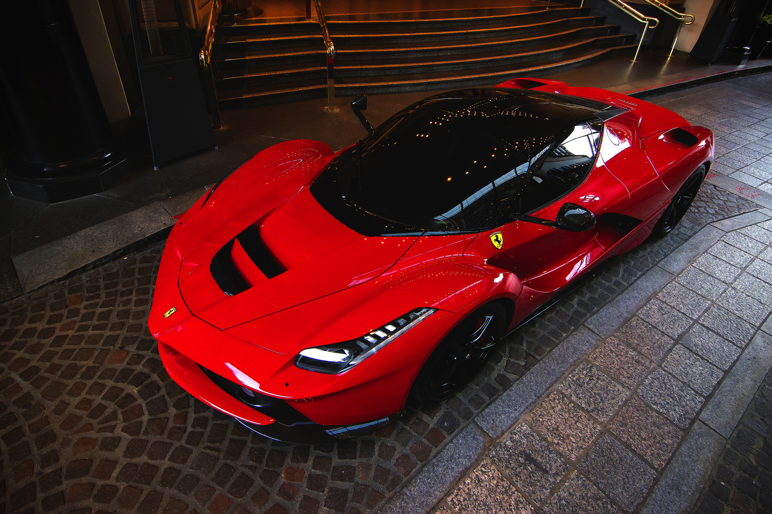
Figure 2: Ferrari LaFerrari. Image courtesy Flickr user “gfreeman23.”

3 Third Section Heading

Ut sagittis arcu ut turpis sodales, nec venenatis magna efficitur. Fusce non rhoncus risus, ac tincidunt arcu. Nulla lacus odio, accumsan tempor dolor sit amet, tincidunt porttitor justo. Quisque
vulputate ex ac purus ultrices tristique. Pellentesque habitant morbi tristique senectus et netus et malesuada fames ac turpis egestas. Curabitur sed ullamcorper metus. Phasellus eu purus eget leo vulputate auctor vel scelerisque velit.

Nunc vitae lorem nec diam ultrices fringilla. Aliquam volutpat metus ut magna bibendum, sed ultricies nunc placerat. Nulla volutpat rutrum vehicula. Cum sociis natoque penatibus et magnis dis parturient montes, nascetur ridiculus mus. Aliquam vel ligula elit. Nulla fermentum purus eu venenatis mollis. Nulla placerat dui accumsan urna pharetra maximus. Sed nec orci arcu. Suspendisse faucibus blandit libero ut feugiat. Nulla vitae imperdiet nulla. Cum sociis natoque penatibus et magnis dis parturient montes, nascetur ridiculus mus.

Etiam sed mattis justo. Mauris lorem sapien, pellentesque vel viverra varius, porta ut nisi. Cras vel interdum dui, vitae fermentum elit. Nulla eu libero finibus, bibendum elit nec, ullamcorper velit. Donec ultrices, purus id ullamcorper euismod, ipsum erat sodales augue, ut sagittis sapien magna nec ex. Nulla massa arcu, suscipit non molestie ut, tristique id tellus. Maecenas nec malesuada mauris, vitae mattis sem. Quisque at risus quis arcu eleifend lacinia non sed neque.

Acknowledgements

To Robert, for all the bagels.

References

Agarwal, S., Mierle, K., and Others. Ceres solver.
https://code.google.com/p/ceres-solver/.

Anonymous, 1976. Planes of the head.
http://www.planesofthehead.com/.

Fedkiw, R., Stam, J., and Jensen, H. W. 2001. Visual simulation of smoke. In Proceedings of SIGGRAPH 2001, ACM Press / ACM SIGGRAPH, E. Fiume, Ed., Computer Graphics Proceedings, Annual Conference Series, ACM, 15–22.

Jobson, D. J., Rahman, Z., and Woodell, G. A. 1995. Retinex image processing: Improved fidelity to direct visual observation. In Proceedings of the IS&T Fourth Color Imaging Conference: Color Science, Systems, and Applications, vol. 4, The Society for Imaging Science and Technology, 124–125.

Kartch, D. 2000. Efficient Rendering and Compression for Full- Parallax Computer-Generated Holographic Stereograms. PhD thesis, Cornell University.

Landis, H., 2002. Global illumination in production. ACM SIGGRAPH 2002 Course #16 Notes, July.

Levoy, M., Pulli, K., Curless, B., Rusinkiewicz, S., Koller, D., Pereira, L., Ginzton, M., Anderson, S., Davis, J., Ginsberg, J., Shade, J., and Fulk, D. 2000. The digital michelangelo project. In Proceedings of SIGGRAPH 2000, ACM Press / ACM SIGGRAPH, New York, K. Akeley, Ed., Computer Graphics Proceedings, Annual Conference Series, ACM, 131–144.

Park, S. W., Linsen, L., Kreylos, O., Owens, J. D., and Hamann, B. 2006. Discrete sibson interpolation. IEEE Transactions on Visualization and Computer Graphics 12, 2 (Mar./Apr.), 243–253.

Parke, F. I., and Waters, K. 1996. Computer Facial Animation. A. K. Peters.

Pellacini, F., Vidimce, K., Lefohn, A., Mohr, A., Leone, M., and Warren, J. 2005. Lpics: a hybrid hardware accelerated relighting engine for computer cinematography. ACM Transactions on Graphics 24, 3 (Aug.), 464–470.

Sako, Y., and Fujimura, K. 2000. Shape similarity by homotropic deformation. The Visual Computer 16, 1, 47–61.

Yee, Y. L. H. 2000. Spatiotemporal sensistivity and visual attention for efficient rendering of dynamic environments. Master’s thesis, Cornell University.

